Aayush Rana Magar

cn lab cheat sheet

In loving memory of

Harembe

~Gone but not forgotten



Contents

Router configuration 1

CLI in router 2

Static routing 4

for 1st router 4

in cli sintax 4

for router 3 5

for router 2 5

C:\>ping 192.168.3.3 5

Dynamic Routing 6

For router 1 6

For router 2 7

For router 3 7

C:\>ping 192.168.3.3 8

VLAN 9

vlan 10 for IT and vlan 20 for cmp 9

Port access 10

Router config 12

C:\>ping 192.168.2.2 13

DHPC 14

Ip of port 14

excluded 15

network 1 15

network 2 15

C:\>ping 192.168.2.4 15

Bibliography 17

# Router configuration

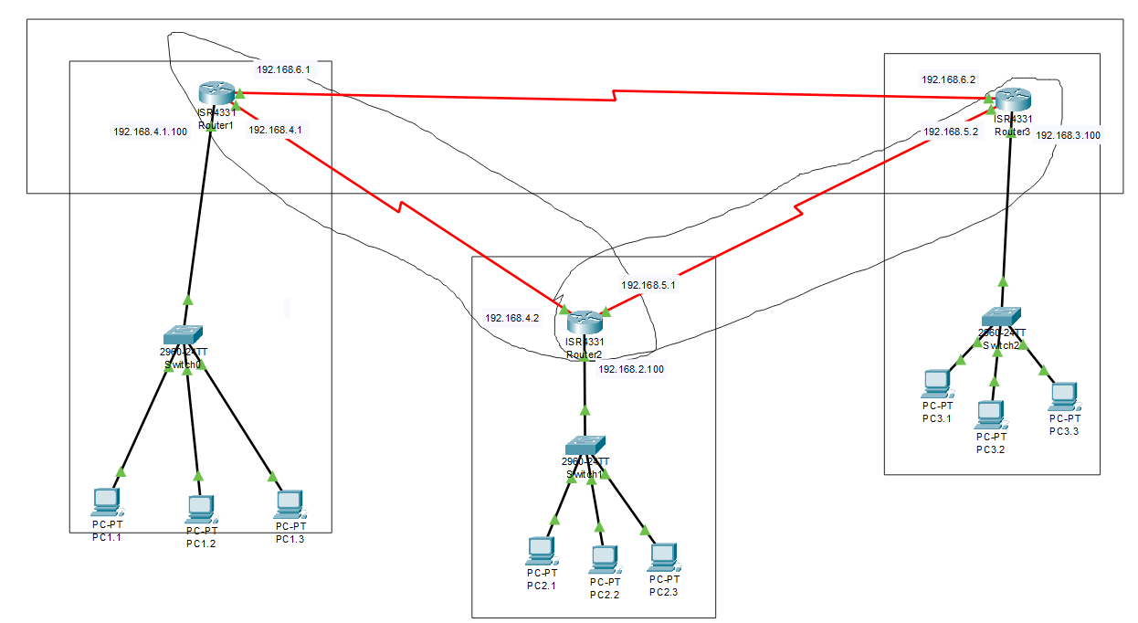

For you will not be able to connect more than 2 connection in router so Do this.

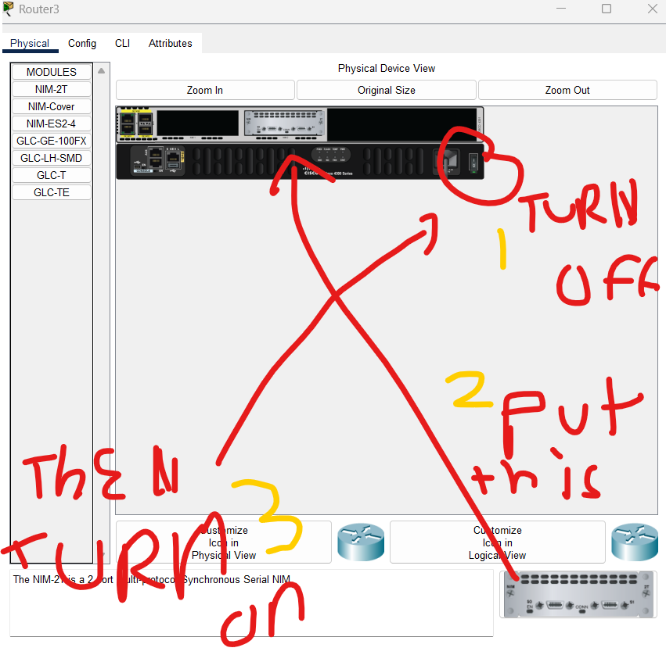

Then you can able to configure that new work

Now we assign ip to different pc > desktop > and ip configuration where you will assign ip address , sub mask and gate way address [1]

## CLI in router

|  |  |
| --- | --- |
| CLI command | What it does |
| Router > enable | Give you access to routers settings |
| Router# configure terminal | You are choosing to change the settings of terminal |
| Router (config)# interface < name of the port > | Giving you the access of that port |
| Router (config-if)# ip address < ip address for that port> <sub mask> | Assigning a ip address to that port |
| Router (config-if)# no shutdown | It activates the interface |

Eg:

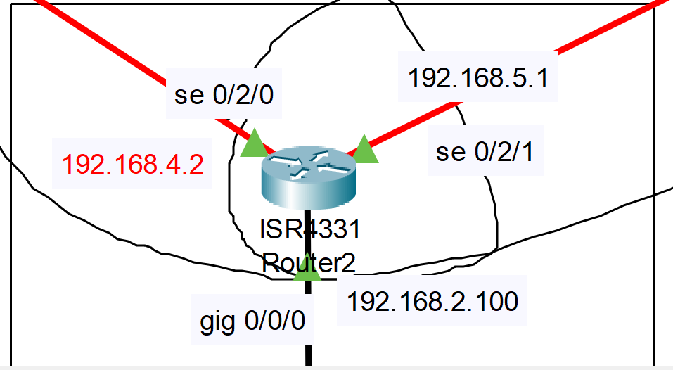

Let us try giving following Ip to the respective ports of router 2:

Router > enable

Router# configure terminal

Router (config)# interface se0/2/0

Router (config-if)# ip address 192.168.4.2 255.255.255.0

Router (config-if)# no shutdown

Router (config)# interface se0/2/1

Router (config-if)# ip address 192.168.5.1 255.255.255.0

Router (config-if)# no shutdown

Router (config)# interface gig0/0/0

Router (config-if)# ip address 192.168.4.2 255.255.255.0

Router (config-if)# no shutdown

And to check you write a CLI command

Router# show ip interface brief

And we should get it like

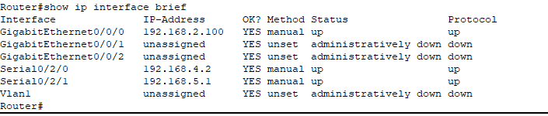

Do this for all available routers

Congrats you have configured the routers

# Static routing

Configure routers as shown above

You need to figure out different networks of in the architecture that is not directly connected to the router and write the command according to it/



## for 1st router

routing to be done with network 2,3,5

to go to network 2 from router0 we need to go through 192.168.4.2 (next hop ip)

to go to network 3 from router0 we need to go through 192.168.4.2 (next hop ip)

to go to network 5 from router0 we need to go through 192.168.4.2 (next hop ip)

## in cli sintax

Router (config)# ip route <network address of destination > <sub mask> <ip address of next hop>

Router (config)# ip route 192.168.2.0 255.255.255.0 192.168.4.2

Router (config)# ip route 192.168.3.0 255.255.255.0 192.168.4.2

Router (config)# ip route 192.168.5.0 255.255.255.0 192.168.4.2

Similarly for others routers

## for router 3

ip route 192.168.2.0 255.255.255.0 192.168.5.1

ip route 192.168.4.0 255.255.255.0 192.168.5.1

ip route 192.168.1.0 255.255.255.0 192.168.5.1

## for router 2

ip route 192.168.3.0 255.255.255.0 192.168.5.2

ip route 192.168.1.0 255.255.255.0 192.168.4.1

to check if the static routing is success we ping from pc1.1 to pc 3.3

if yes the command prompts shoul look like this

isco Packet Tracer PC Command Line 1.0

## C:\>ping 192.168.3.3

Pinging 192.168.3.3 with 32 bytes of data:

Request timed out.

Reply from 192.168.3.3: bytes=32 time=2ms TTL=125

Reply from 192.168.3.3: bytes=32 time=26ms TTL=125

Reply from 192.168.3.3: bytes=32 time=2ms TTL=125

Ping statistics for 192.168.3.3:

Packets: Sent = 4, Received = 3, Lost = 1 (25% loss),

Approximate round trip times in milli-seconds:

Minimum = 2ms, Maximum = 26ms, Average = 10ms

# Dynamic Routing

Configure routers as shown above

You do it using RIP

So just route by rip and give every available network in the architecture

This should be done in every router in the architecture.



## For router 1

Router>enable

Router#

Router#configure terminal

Enter configuration commands, one per line. End with CNTL/Z.

Router(config)#router rip

Router(config-router)#network 192.168.1.0

Router(config-router)#network 192.168.2.0

Router(config-router)#network 192.168.3.0

Router(config-router)#network 192.168.4.0

Router(config-router)#network 192.168.5.0

Router(config-router)#network 192.168.6.0

## For router 2

Router>enable

Router#

Router#configure terminal

Enter configuration commands, one per line. End with CNTL/Z.

Router(config)#router rip

Router(config-router)#network 192.168.1.0

Router(config-router)#network 192.168.2.0

Router(config-router)#network 192.168.3.0

Router(config-router)#network 192.168.4.0

Router(config-router)#network 192.168.5.0

Router(config-router)#network 192.168.6.0

## For router 3

Router>enable

Router#

Router#configure terminal

Enter configuration commands, one per line. End with CNTL/Z.

Router(config)#router rip

Router(config-router)#network 192.168.1.0

Router(config-router)#network 192.168.2.0

Router(config-router)#network 192.168.3.0

Router(config-router)#network 192.168.4.0

Router(config-router)#network 192.168.5.0

Router(config-router)#network 192.168.6.0

to check if the static routing is success we ping from pc1.1 to pc 3.3

if yes the command prompts should look like this

isco Packet Tracer PC Command Line 1.0

## C:\>ping 192.168.3.3

Pinging 192.168.3.3 with 32 bytes of data:

Request timed out.

Reply from 192.168.3.3: bytes=32 time=2ms TTL=125

Reply from 192.168.3.3: bytes=32 time=26ms TTL=125

Reply from 192.168.3.3: bytes=32 time=2ms TTL=125

Ping statistics for 192.168.3.3:

Packets: Sent = 4, Received = 3, Lost = 1 (25% loss),

Approximate round trip times in milli-seconds:

Minimum = 2ms, Maximum = 26ms, Average = 10ms

# VLAN

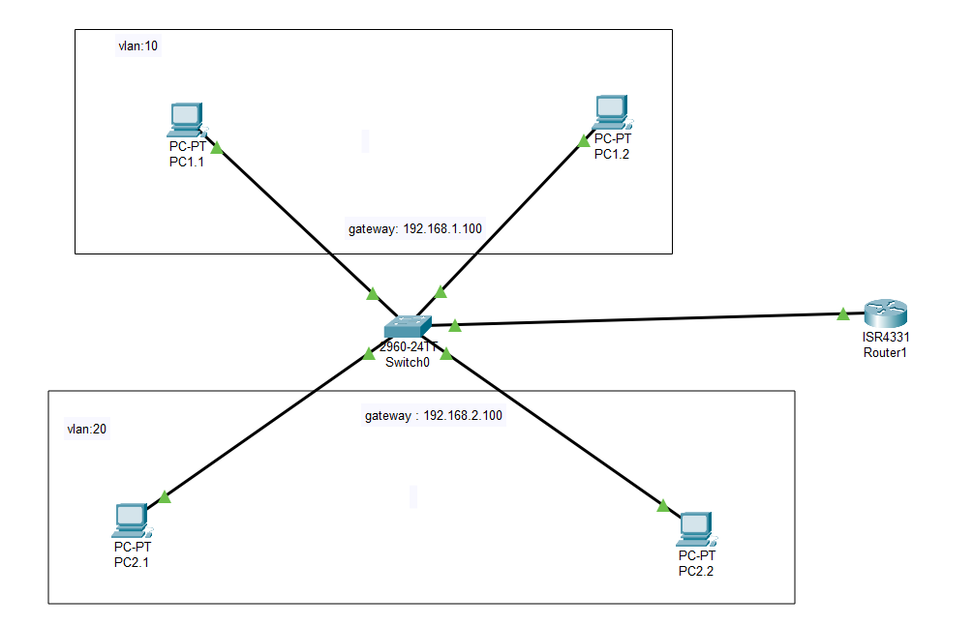

Usually pcs are connected in same network but what if there are different networks in a single switch . then it will have to encapsulate two LAN in a single switch. Aka a virtual LAN, a VLAN

While putting ip make sure to put the correct gate way.

We are making 2 vlan,

## vlan 10 for IT and vlan 20 for cmp

Switch#configure terminal

Enter configuration commands, one per line. End with CNTL/Z.

Switch(config)#vlan 10

Switch(config-vlan)#name IT

Switch(config-vlan)#vlan 20

Switch(config-vlan)#name CMP

Switch(config-vlan)#do show vlan brief

VLAN Name Status Ports

---- -------------------------------- --------- -------------------------------

1 default active Fa0/1, Fa0/2, Fa0/3, Fa0/4

Fa0/5, Fa0/6, Fa0/7, Fa0/8

Fa0/9, Fa0/10, Fa0/11, Fa0/12

Fa0/13, Fa0/14, Fa0/15, Fa0/16

Fa0/17, Fa0/18, Fa0/19, Fa0/20

Fa0/21, Fa0/22, Fa0/23, Fa0/24

Gig0/1, Gig0/2

10 IT active

20 CMP active

1002 fddi-default active

1003 token-ring-default active

1004 fddinet-default active

1005 trnet-default active

## Port access

Then we give vlan 10 access to port Fa0/1, Fa0/2 and vlan 20 access to port Fa0/3, Fa0/4 and make port Gig0/1 trunk (The switchport mode trunk command **converts the port into a trunk**, allowing it to **carry traffic for multiple VLANs** between switches.)

Switch(config-vlan)#exit

Switch(config)#vlan 10

Switch(config-vlan)#int fa0/1

Switch(config-if)#switchport mode access

Switch(config-if)#switchport access vlan 10

Switch(config-if)#int fa0/2

Switch(config-if)#switchport mode access

Switch(config-if)#switchport access vlan 10

Switch(config-if)#vlan 20

Switch(config-vlan)#int fa0/3

Switch(config-if)#switchport mode access

Switch(config-if)#switchport access vlan 20

Switch(config-if)#int fa0/4

Switch(config-if)#switchport mode access

Switch(config-if)#switchport access vlan 20

Switch(config)#interface GigabitEthernet0/1

Switch(config-if)#

Switch(config-if)#switchport mode trunk

Switch(config-if)#

Switch(config-if)#exit

Switch(config-vlan)#do show vlan

VLAN Name Status Ports

---- -------------------------------- --------- -------------------------------

1 default active Fa0/5, Fa0/6, Fa0/7, Fa0/8

Fa0/9, Fa0/10, Fa0/11, Fa0/12

Fa0/13, Fa0/14, Fa0/15, Fa0/16

Fa0/17, Fa0/18, Fa0/19, Fa0/20

Fa0/21, Fa0/22, Fa0/23, Fa0/24

Gig0/2

10 IT active Fa0/1, Fa0/2

20 CMP active Fa0/3, Fa0/4

1002 fddi-default active

1003 token-ring-default active

1004 fddinet-default active

1005 trnet-default active

## Router config

Then in router, configuration is setting up **Inter-VLAN Routing** using a **Router-on-a-Stick** setup. Here’s what each part does:

**Configure the Physical Interface**

Activates the **physical** GigabitEthernet0/0/0 interface.

This interface will be used for **subinterfaces** (VLANs).

**Create a Subinterface for VLAN 10**

interface GigabitEthernet0/0/0.10 → Creates a subinterface for VLAN **10**.

encapsulation dot1q 10 → Tags this subinterface with **VLAN 10**.

ip address 192.168.1.100 255.255.255.0 → Assigns an IP to **VLAN 10 Gateway**.

**Create a Subinterface for VLAN 20**

interface GigabitEthernet0/0/0.20 → Creates a subinterface for VLAN **20**.

encapsulation dot1q 20 → Tags this subinterface with **VLAN 20**.

ip address 192.168.2.100 255.255.255.0 → Assigns an IP to **VLAN 20 Gateway**.

Router>enable

Router#

Router#configure terminal

Enter configuration commands, one per line. End with CNTL/Z.

Router(config)#interface GigabitEthernet0/0/0

Router(config-if)#no shutdown

Router(config-if)#

Router(config-if)#interface GigabitEthernet0/0/0.10

Router(config-subif)#

Router(config-subif)#encapsulation dot1q 10

Router(config-subif)#ip add 192.168.1.100 255.255.255.0

Router(config-subif)#interface GigabitEthernet0/0/0.20

Router(config-subif)#

Router(config-subif)#encapsulation dot1q 20

Router(config-subif)#ip add 192.168.2.100 255.255.255.0

Router(config-subif)#exit

Router(config)#end

Then to check if this worked

We ping pc2.2 from pc 1.1

## C:\>ping 192.168.2.2

Pinging 192.168.2.2 with 32 bytes of data:

Request timed out.

Reply from 192.168.2.2: bytes=32 time=1ms TTL=127

Reply from 192.168.2.2: bytes=32 time=1ms TTL=127

Reply from 192.168.2.2: bytes=32 time<1ms TTL=127

Ping statistics for 192.168.2.2:

Packets: Sent = 4, Received = 3, Lost = 1 (25% loss),

Approximate round trip times in milli-seconds:

Minimum = 0ms, Maximum = 1ms, Average = 0ms

# DHPC

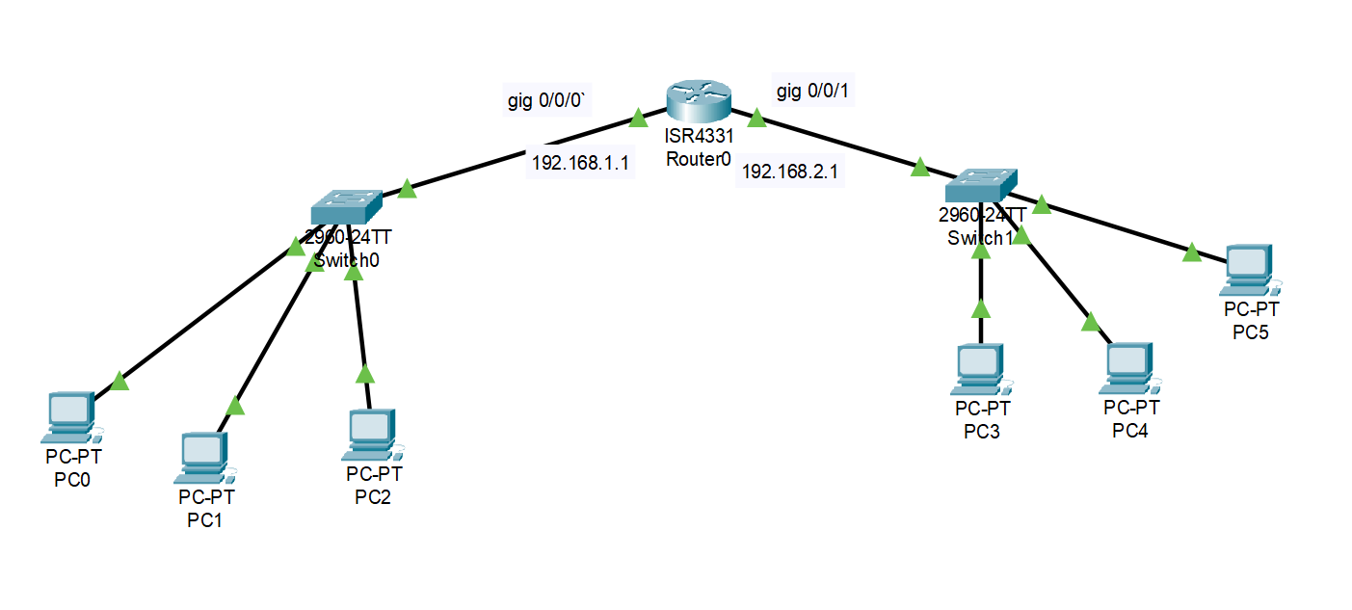

In dchp the ip is suppose to be given automatically for that. We give ip to the ports of the router which will act as a gate way to the network.

## Ip of port

Router>enable

Router#configure terminal

Router(config)#hostname dhpc-server

dhpc-server(config)#interface gig0/0/0

dhpc-server(config-if)#ip address 192.168.1.1 255.255.255.0

dhpc-server(config-if)#no shutdown

dhpc-server(config-if)#interface gig0/0/1

dhpc-server(config-if)#ip address 192.168.2.1 255.255.255.0

dhpc-server(config-if)#no shutdown

dhpc-server(config-if)#exit

## excluded

then we exclude the gateway address from the pool so that no other pc will receive those address

dhpc-server(config)#ip dhcp excluded-address 192.168.1.1

dhpc-server(config)#ip dhcp excluded-address 192.168.2.1

## network 1

then for pool of ip in network 192.168.1.0 will be accessed through 192.168.1.1

dhpc-server(config)#ip dhcp pool 192.168.1.1

dhpc-server(dhcp-config)#network 192.168.1.0 255.255.255.0

dhpc-server(dhcp-config)#default-router 192.168.1.1

dhpc-server(dhcp-config)#dns-server 8.8.8.8

dhpc-server(dhcp-config)#exit

## network 2

then for pool of ip in network 192.168.2.0 will be accessed through 192.168.2.1

dhpc-server(config)#ip dhcp pool 192.168.2.1

dhpc-server(dhcp-config)#network 192.168.2.0 255.255.255.0

dhpc-server(dhcp-config)#default-router 192.168.2.1

dhpc-server(dhcp-config)#dns-server 8.8.8.8

dhpc-server(dhcp-config)#exit

then in ip configuration of every pc we turn on the dhpc options and automatically receive ip, mask, gateway and dns address

pinging pc2 192.168.1.4 to pc 3 192.168.2.4

## C:\>ping 192.168.2.4

Pinging 192.168.2.4 with 32 bytes of data:

Request timed out.

Reply from 192.168.2.4: bytes=32 time<1ms TTL=127

Reply from 192.168.2.4: bytes=32 time<1ms TTL=127

Reply from 192.168.2.4: bytes=32 time<1ms TTL=127

Ping statistics for 192.168.2.4:

Packets: Sent = 4, Received = 3, Lost = 1 (25% loss),

Approximate round trip times in milli-seconds:

Minimum = 0ms, Maximum = 0ms, Average = 0ms

# Bibliography

|  |  |
| --- | --- |
| [1] | me, "I made it the fuck up". |